Dated 21.05.2024

**Hands on ElastiCache**

Database services

Amazon ElastiCache

Real-time performance for real-time applications

Delivers real-time performance, and enables applications to scale instantly. ElastiCache is compatible with two open-source caching solutions: Redis and Memcached.

URL : https://aws.amazon.com/elasticache/redis-vs-memcached/

URL : https://aws.amazon.com/elasticache/pricing/

Lab

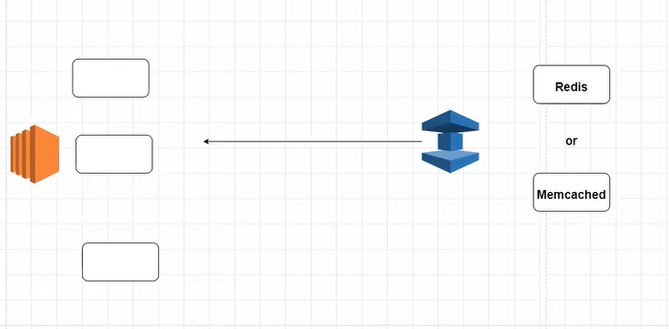

Go to Amazon Elasticashe

Create a ElastiCache

Choose Memchached

Select memcashed

Deployment option >>> Design your own cache

Location AWS Cloud

creation method >>> Standard Create

Location >> AWS Cloud

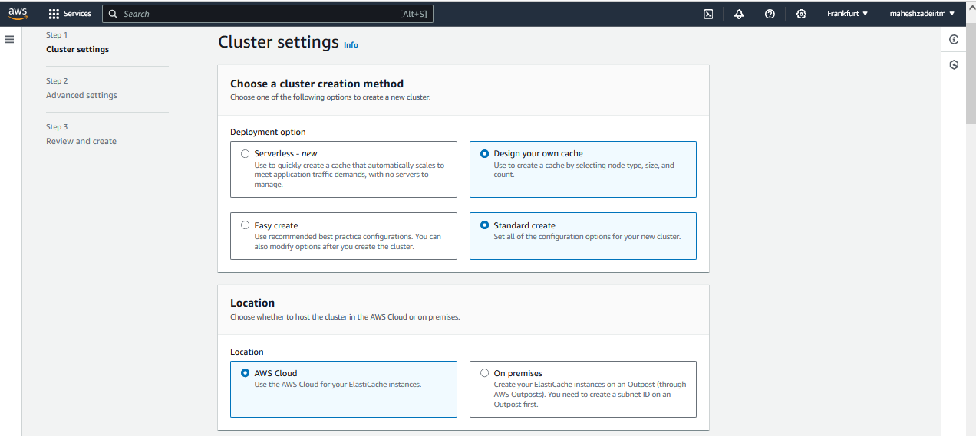

Cluster name - MyElastiCache

Leave all the Cluster settings as it is, except below

Node type >> cache.t2.micro

Number of nodes >>> 1

Create Subnet Group

Name – mySubnetGroup

Choose your VPC

Selected subnets >>> Choose your Public Subnets

Availability Zone >>> No preference

Next

Selected security groups >>> Choose your above SG

Create a "Dedicated SG "

ALL TCP >> anywhere

SSH >> anywhere

Now Click on Manage in Elastcashe

Select created SG and click on choose

Maintenance >>> No preference

Next, Review and Create

Keep all the setting as it is

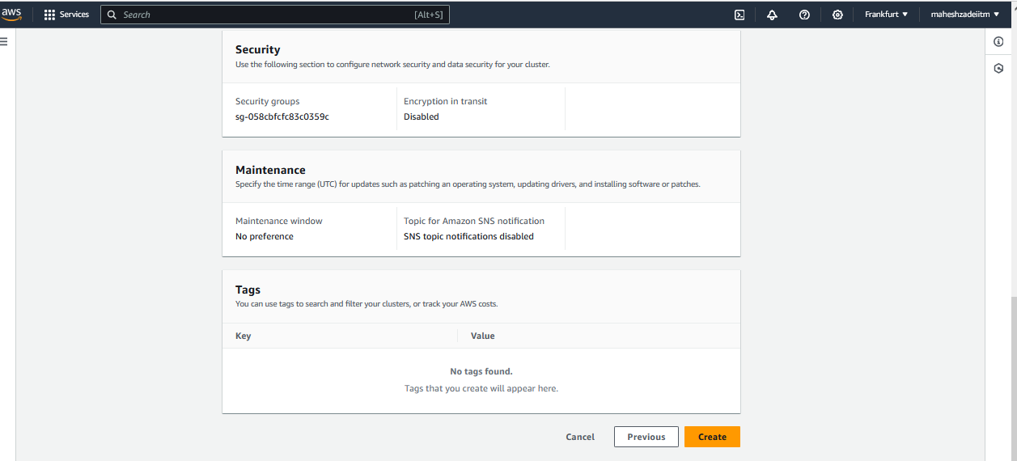

it will take time to create and you will get your endpoint

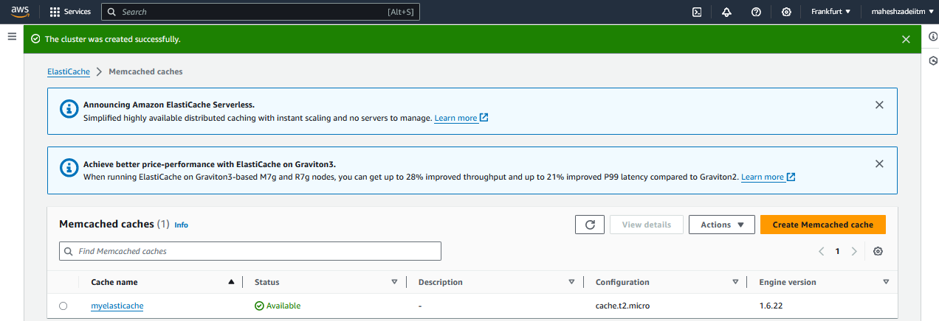

Make a note of your endpoint >>> myelasticache.y86dxt.cfg.apse1.cache.amazonaws.com:11211

My endpoint : myelasticache.gbaewr.0001.euc1.cache.amazonaws.com:11211

Launch a "AMazon LInux 2" EC2 in public subnet using the above SG

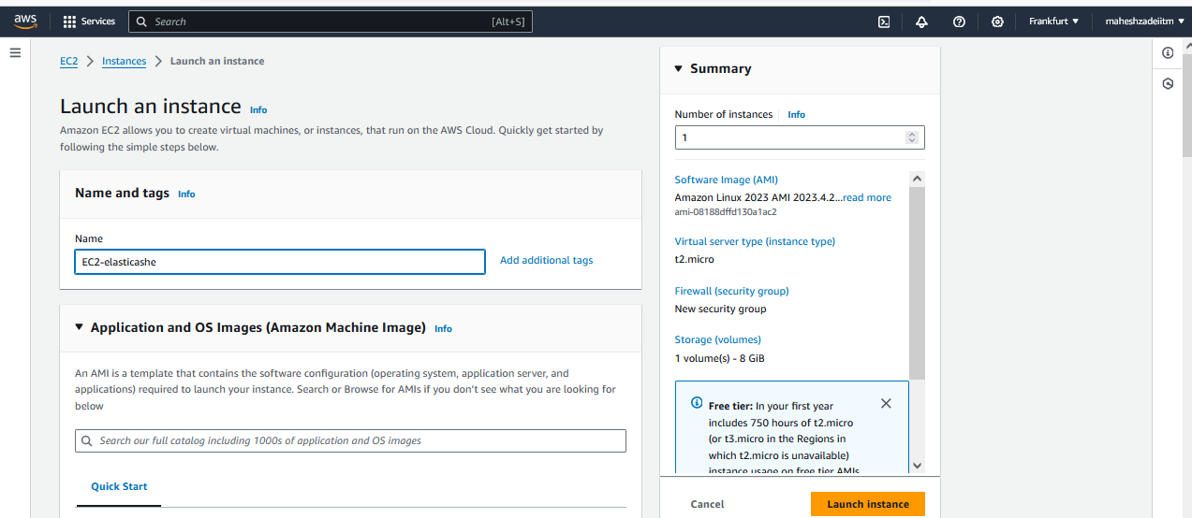

Select the OS Amazon2

Select the t2.micro and without keypair

Select the default vpc

launch instance

Insatnce created

Once you logged in

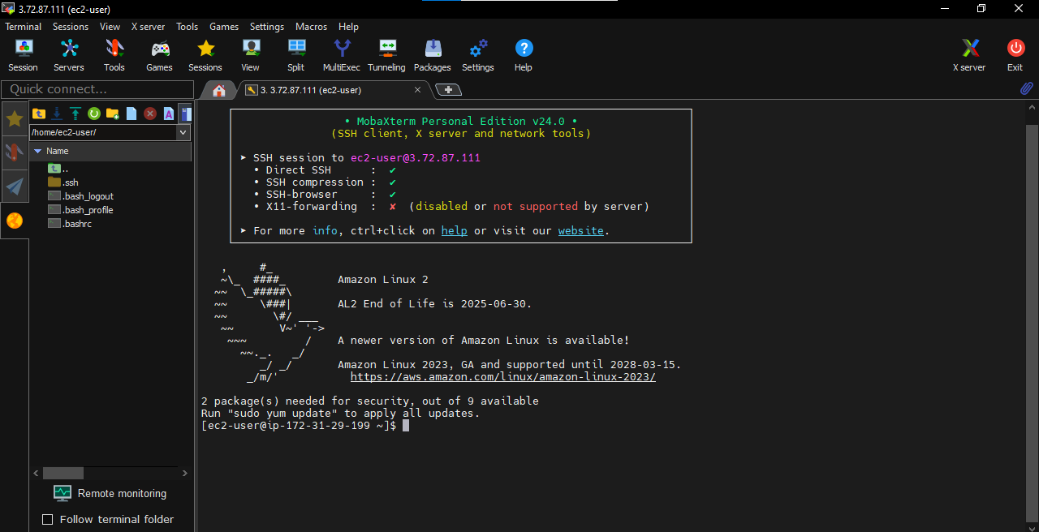

sudo su

yum install telnet

telnet <your enpoint>

# dont forget to remove ":" and give a space before port number

myelasticache.gbaewr.0001.euc1.cache.amazonaws.com:11211

telnet myelasticache.gbaewr.0001.euc1.cache.amazonaws.com 11211

once you see your endpoint is connected you can set your values and try with the get

set <your suffix> 0 0 <your preferred number >

get <your suffix>

example - set name 0 0 6

mahesh

set name 0 0 3

hai

set name 0 0 5

manas

get name

again you can try with new number but with same suffix.

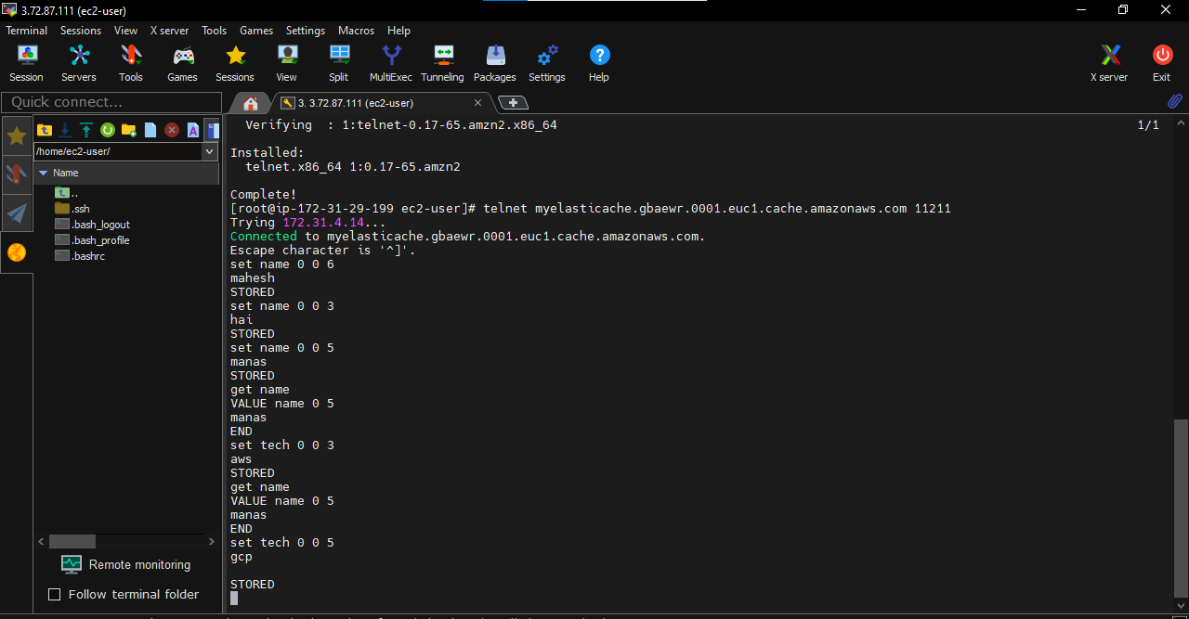

Hence proved our Elasticashe provide Realtime data from its in memory.

Thanks

Pls check and confirm .

